MIT Assignment-04

Jeetu Mehra
U24AI032

Question 1 : Write instruction to increment the contents of a register and show result to memory location
0008H.
Output:

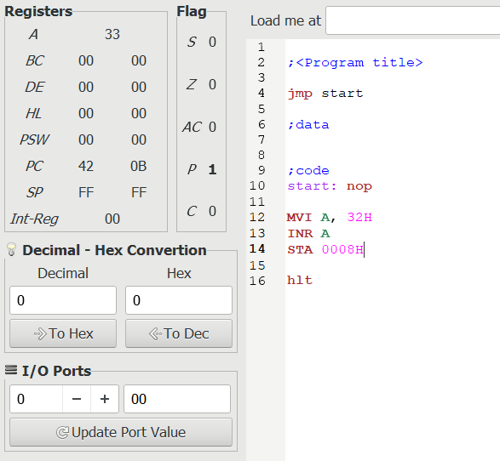
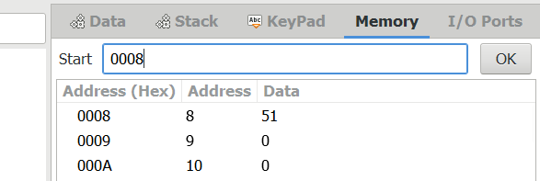

Question 2: Write instruction to increment the contents of a memory location the address of which is in HL Pair.
Output:
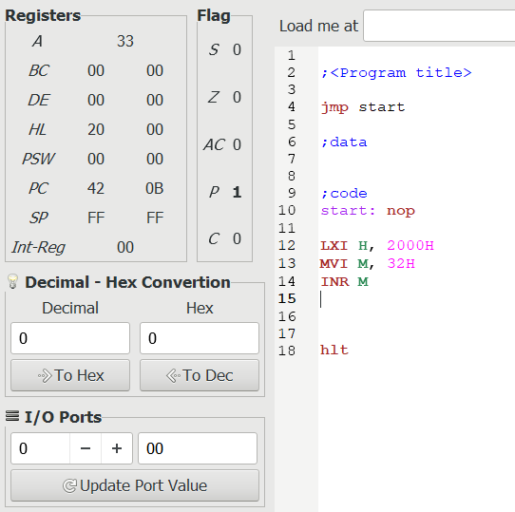
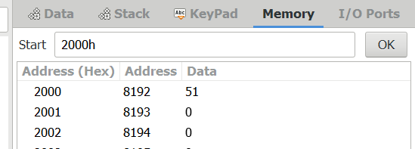

Question 3: Write instruction to decrement the contents of a register and show result to I/O port address 0009H.
Output:
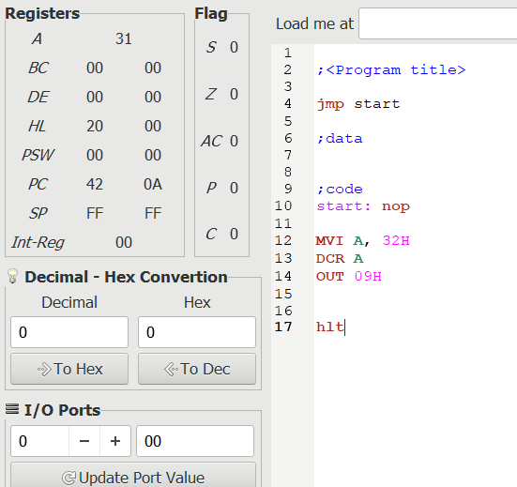
Question 4 : Write instruction to decrement the contents of a memory location the address of which is in HL
pair and copy that result to register B.
Output:
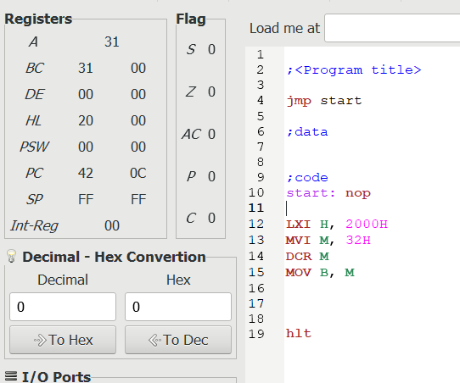

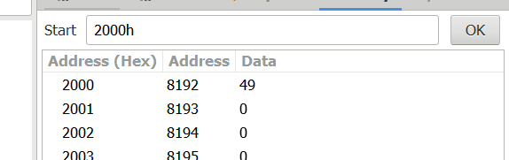

Question 5 : Write instruction to increment the contents of a register-pair and show result to memory location 003FH.
Output:
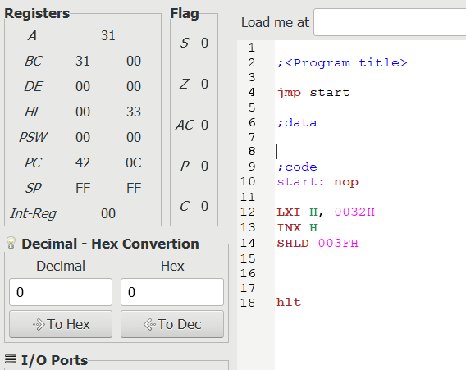

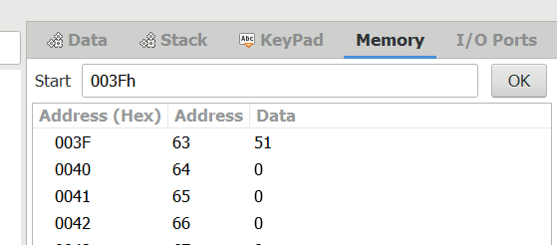

Question 6 : Write instruction to decrement the contents of a register-pair and show result to memory location 005FH.
Output:
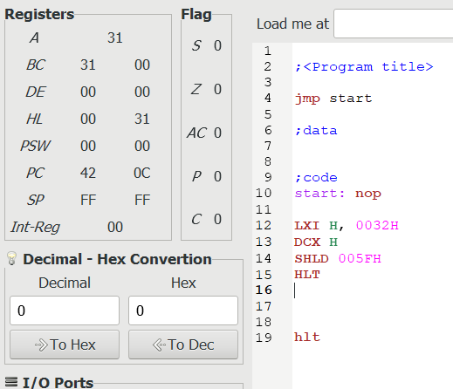

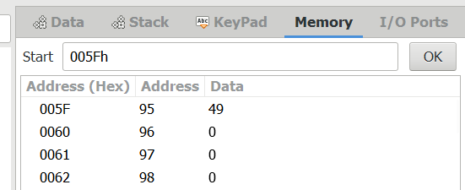

Question 7 : Write instruction to do following operations:
a. Load 93H in Accumulator.
b. Load B7 H in register C.
c. Addition of the above two numbers.
Output:
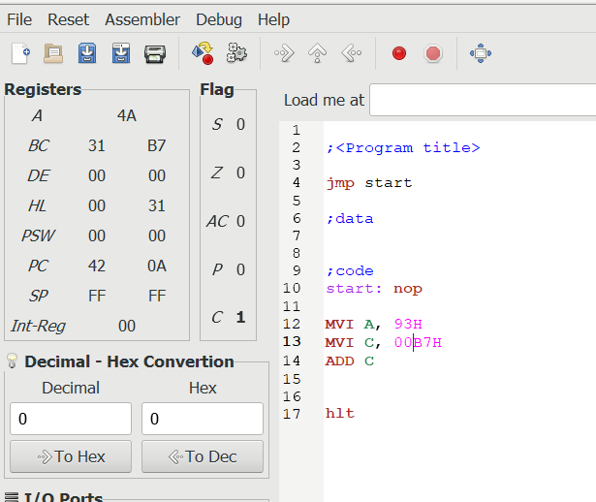

Question 8 : Write instruction to add the 35H to the sum in the previous example when the carry flag is set.
Output:
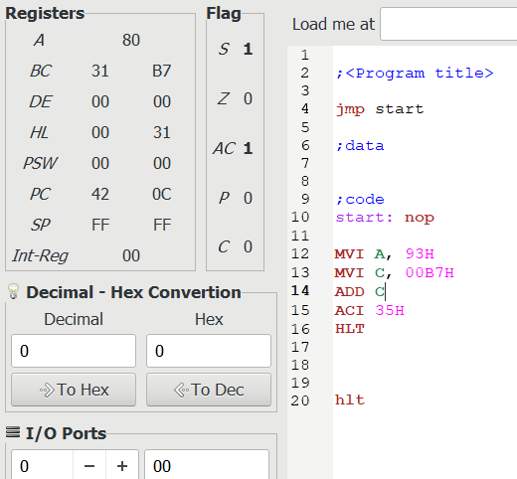

Question 9 : a. Assume the accumulator holds the data byte FFH.By adding 01H comment about the conditions of all flags.
b. After that increment the content of A and comments about the conditions of flags
Output:
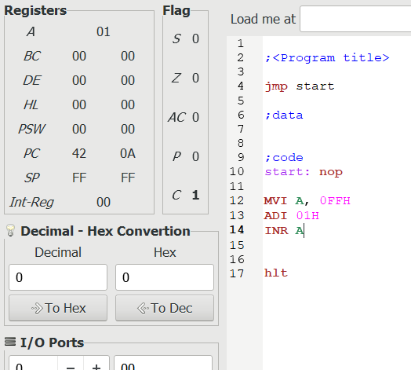

Question 10 : Write instruction to do following operations:
a. Load 8BH in C.
b. Load 6FH in register D.
c. Increment the contents of C by one.
d. Addition of the contents in C and D and display the sum at the PORT address 001FH.
Output:
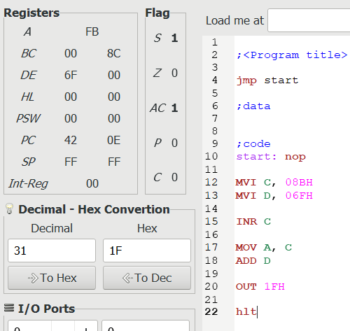

Question 11: Write instruction to do following operations:
a. Load FFH in B.
b. Load 01H in A.
c. Add the contents of B with A.
d. Load 02H in register D.
e. Addition of the contents in D with contents of A with carry.
Output:
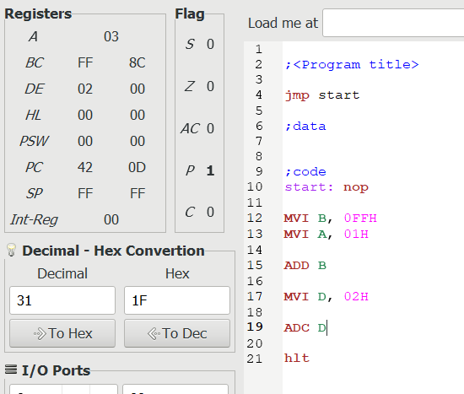

Question 12: Write instruction to perform following operations:

a. Perform Logical AND between the contents of register D (D=54H) with the Contents
of Accumulator (A=82H).
b. Perform Logical AND between the 8-bit data(97H) with the Contents of Accumulator
(A=82H).
c. Perform Logical AND between the contents of memory location with the Contents of
Accumulator (A=72H).
Output:
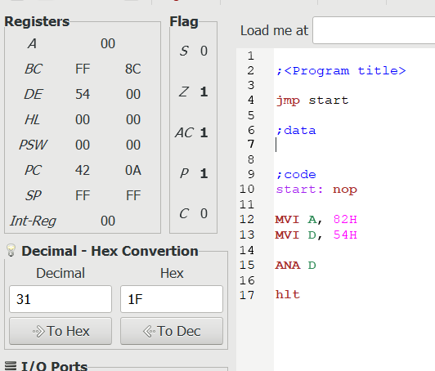
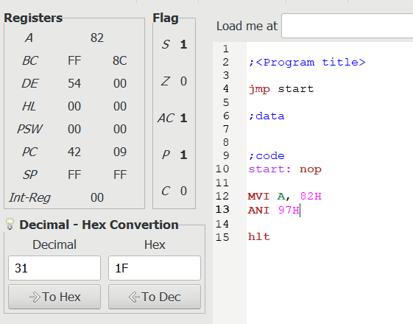
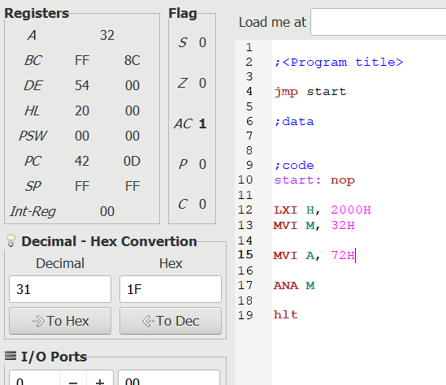

Question 13: Write instruction to perform following operations:

a. Perform Logical OR between the contents of register B (D=51H) with the Contents of
Accumulator (A=A8H).
b. Perform Logical OR between the 8-bit data(A6H) with the Contents of Accumulator
(A=82H).
c. Perform Logical OR between the contents of memory location with the Contents of
Accumulator (A=C2H).
Output:
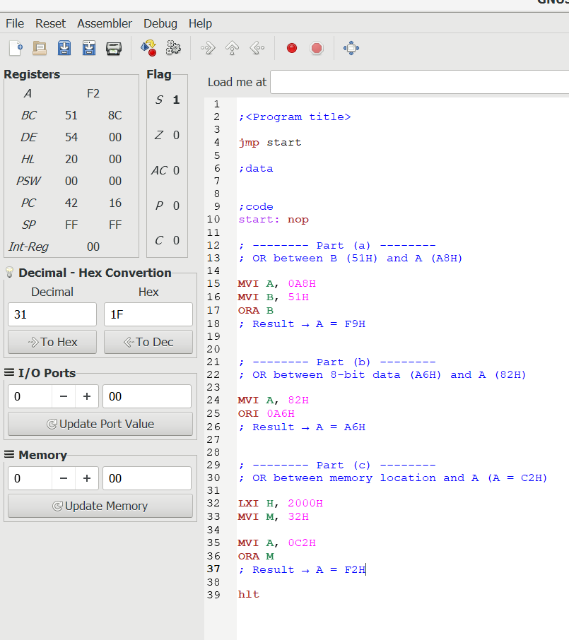

Question 14: Write instruction to perform following operations:

a. Perform Logical Exclusive-OR between the contents of register B (D=77H) with the
Contents of Accumulator (A=56H).
b. Perform Logical Exclusive-OR between the 8-bit data(8FH) with the Contents of
Accumulator (A=A2H).
c. Perform Logical Exclusive-OR between the contents of memory location with the
Contents of Accumulator (A=4AH).
Output:
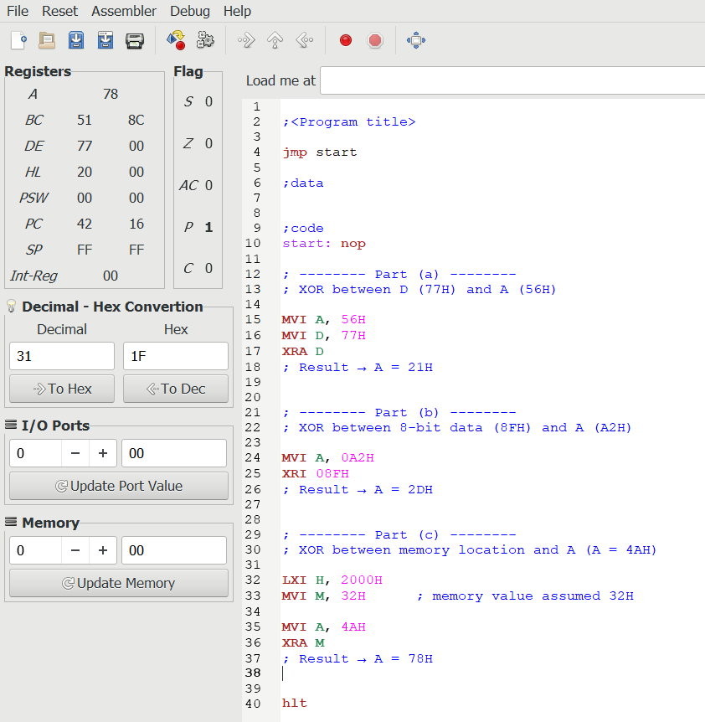

Question 15: Write instruction to perform following operations:

a. Compare the contents of register with the contents of A.
b. Compare the 8-bit data with the contents of A.
c. Complement the contents of A.

d. Complement the Carry
Output:
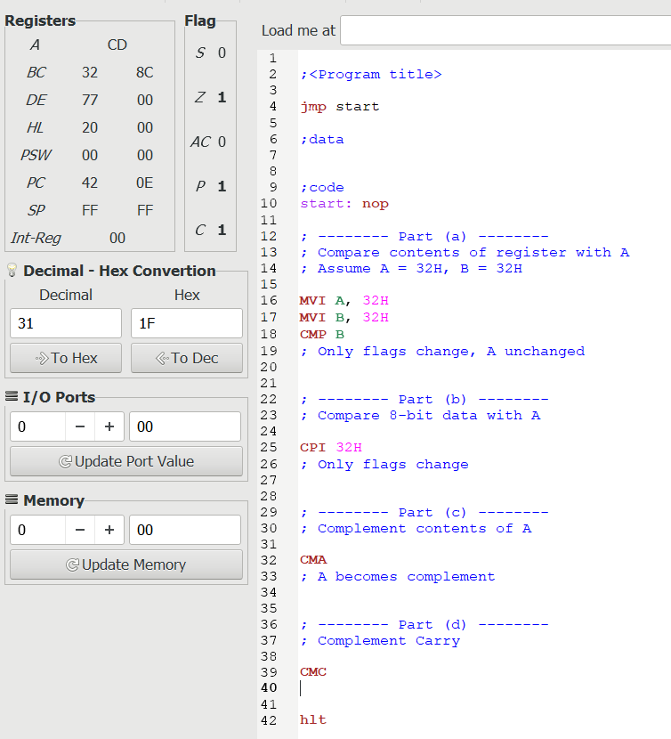

Question 16: Perform 16-bit Addition
Output:
